Gondwanaland and the Geological History of Antarctica Level 3 & 4
Main teaching ideas;
- The development over time of scientific theories to explain continental drift
- There is evidence supporting the theory of Gondwanaland
- Understanding the mechanisms that drive plate tectonics
- Identification of the different boundaries formed by plate tectonics
- Antarctica’s geological history as part of Pangaea and Gondwanaland.
Key words; Pangaea, Gondwanaland, continent, fossil, plate tectonics, paleontologist.

Antarctica and Gondwanaland

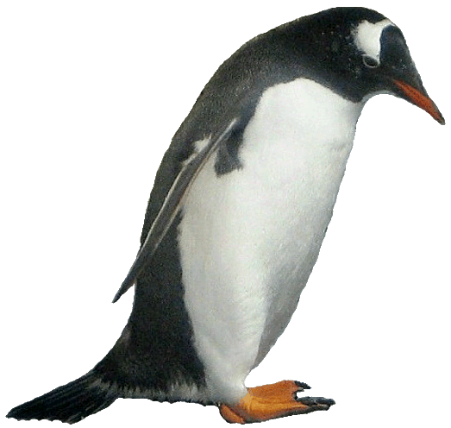 | 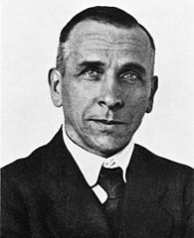  Science History  Scientists had noticed that the coast lines of Africa and South America could fit together.  In the 1920’s Alfred Wegener proposed the theory of continental drift; that there was one super continent, Pangaea, ( meaning all lands ), and that this broke up, forming the continents of today. Originally his ideas were thought to be incorrect as no one could explain how the continents could have moved over time. By the 1960s with increasing scientific evidence and the development of the modern science of plate tectonics, the movements of the Earth’s crust driven by the convection currents in the mantle of the Earth, meant that Wegener’s theory was accepted. We now know that the jigsaw of massive plates on the Earth’s surface are still moving slowly, at a speed of around 5cm a year.  Super Continents  The super continent of Pangaea broke into two main groups of continents that drifted in different directions.  Laurasia which drifted north and separated into Europe, Asia and North America  Gondwanaland which split into Antarctica, New Zealand, Australia, South America, Africa and India.  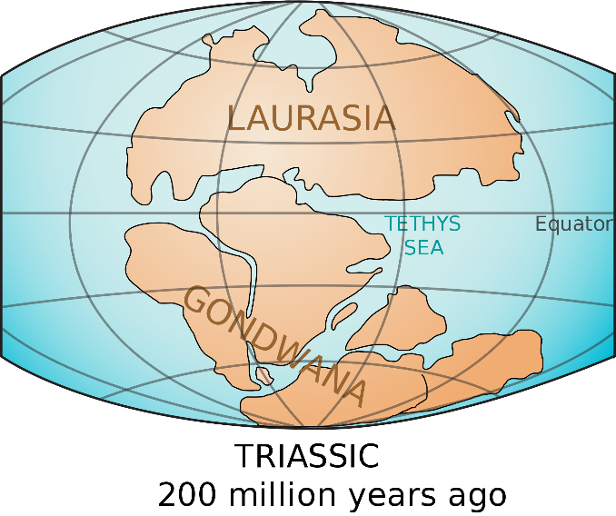  Gondwana  - The name Gondwana comes from the Gonds, an ancient tribe living in India and Wana, which means land.  - Until about 140 million years ago, East Antarctica was the centre of the ancient southern land mass of Gondwana.  - After that time, Gondwana split up into the continents of Antarctica, South America, Africa and India. New Zealand started to break away from Antarctica about 80 million years ago and Australia about 55 million years ago.  - Ancient rocks have been found in Antarctica which are similar to ones in parts of India and Australia.  - Rocks dumped by ice sheets have been found in Antarctica, Australia, India and South Africa.  - Fossil remains of the tree Glossopteris have been found over much of “Gondwana”, including Southland (New Zealand).  - Fossil remains of the fern Dicroidium have been found in Antarctica, South Africa, South America and Australia.  - Fossil remains of the land-based fern-browsing reptile Lystrosaurus have been found in Antarctica, Africa and India. As this reptile couldn’t swim across oceans, the continents must have moved to their present position.
 | 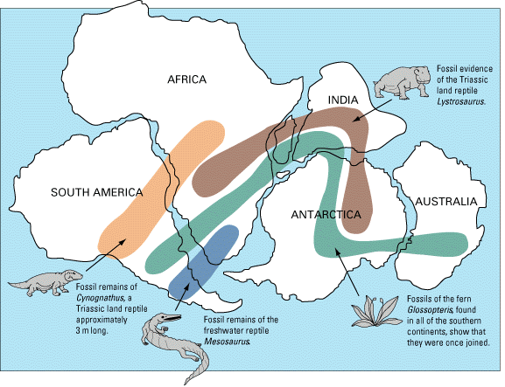
Fossil Evidence
When animals or plants are rapidly buried in layers of mud during a natural catastrophe, their bodies are protected from normal processes of decay: scavengers, bacteria, and chemicals are prevented from breaking down their bodies at the usual rate. The hard parts of the animals (such as their bones, teeth, and shells) are eventually replaced with minerals from the mud, which turn them into rock. The soft parts of the specimen, such as the scales of a fish or the leaves of a plant, sometimes leave a coloured imprint in rock before they eventually decay. Trees or other organic matter that are covered with silica-rich water become petrified--they turn into solid mineral. All of these methods result in what we know as fossils. A palaeontologist is a scientist who studies fossils to find out more about extinct species or about any species that are evident in the fossil record.
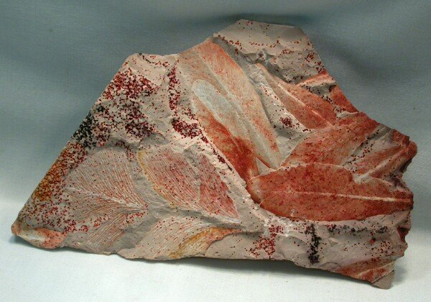
The fossils that link the continents have been important evidence to prove the existence of the super continents of Pangaea and Gondwanaland. Captain Robert Falcon Scott and his expedition party found, and carried back from their ill-fated journey to the South Pole in 1912, fossils of the Glossopteris indica, an ancient beech like tree. This 250 million year old fossil has been found in all the other continents that made up Gondwanaland. Antarctica must have been warmer and ice free for this tree to grow. Glossopteris indica an extinct beech-like tree fossil

Questions/think pair share/discuss
- What is the evidence for Gondwanaland?
- Why do you think people took a long time to understand that the continents were once joined together?
- The India has a research station in Antarctica close to where India was once thought to have been attached to Antarctica. What do you think scientists might be looking for?

Activities
- Make a time line from Gondwanaland to the placement of the present day continents.
- Make a flow chart diagram that shows the division of the super continent Pangaea into Laurasia and Gondwanaland, and then into the continents of today.
- Listen to the Alfred Wegener song https://www.youtube.com/watch?v=T1cES1Ekto
- Watch the information clip on Alfred Wegener’s theory of Continental Drift. Take notes and ideas down. Share main ideas from the clip in the link
http://www.britannica.com/science/continental-drift-geology
- Go to the interactive site below and try the activites there
https://www.learner.org/interactives/dynamicearth/drift3.html

- Use the tectonic plate jigsaw map to see how the plates fit together. Cut and move them around. Notice the way the arrows are moving. What do you think will be happening at the plate boundaries?
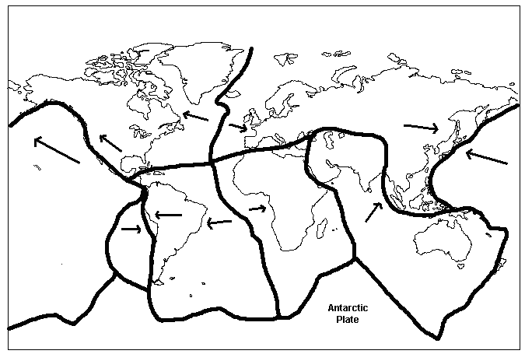
Practical work
Plate movement
- Add cold honey, corn syrup or golden syrup to a beaker. Place two halves of a biscuit on top of the honey or golden syrup. Gradually heat. What happens to the biscuit?
- In a saucepan pour a litre of cream or milk. Add a layer of cocoa powder to cover the milk (2cm). Gradually heat until milk bubbles through. Identify the movement of the cocoa as continental drift.
Making a fossil
Fossils are most commonly found in limestone, shale, and sandstone, all relatively soft rock that erodes more easily than most rocks do. As the rock gradually wears away, the fossil layers within it are exposed. To demonstrate how fossils are made you can make fossil 'casts' or prints out of plaster.
1. Fill a clean tuna can or shallow bowl to a depth of about 3am with modelling clay.
2. Press a plastic animal, rock or other object halfway into the clay
3. Remove the object, leaving a clear imprint in the clay.
4. Mix plaster of paris with water until the consistency is similar to pancake batter. Pour the plater into the can over the clay, filling the imprint.
5. Let the plaster dry for 24 hours.
6. Separate any remaining clay from the plaster to reveal a 'fossil' of the object

