Reading Maps and Using Geospatial Data Answers
Read the Background Pages before attempting the questions | Curriculum Area:  Social Studies Level 3-5 | Strand  Place and Environment  Culture and Organisation  Continuity and Change
Achievement Objectives | Understand how people view and use places differently.
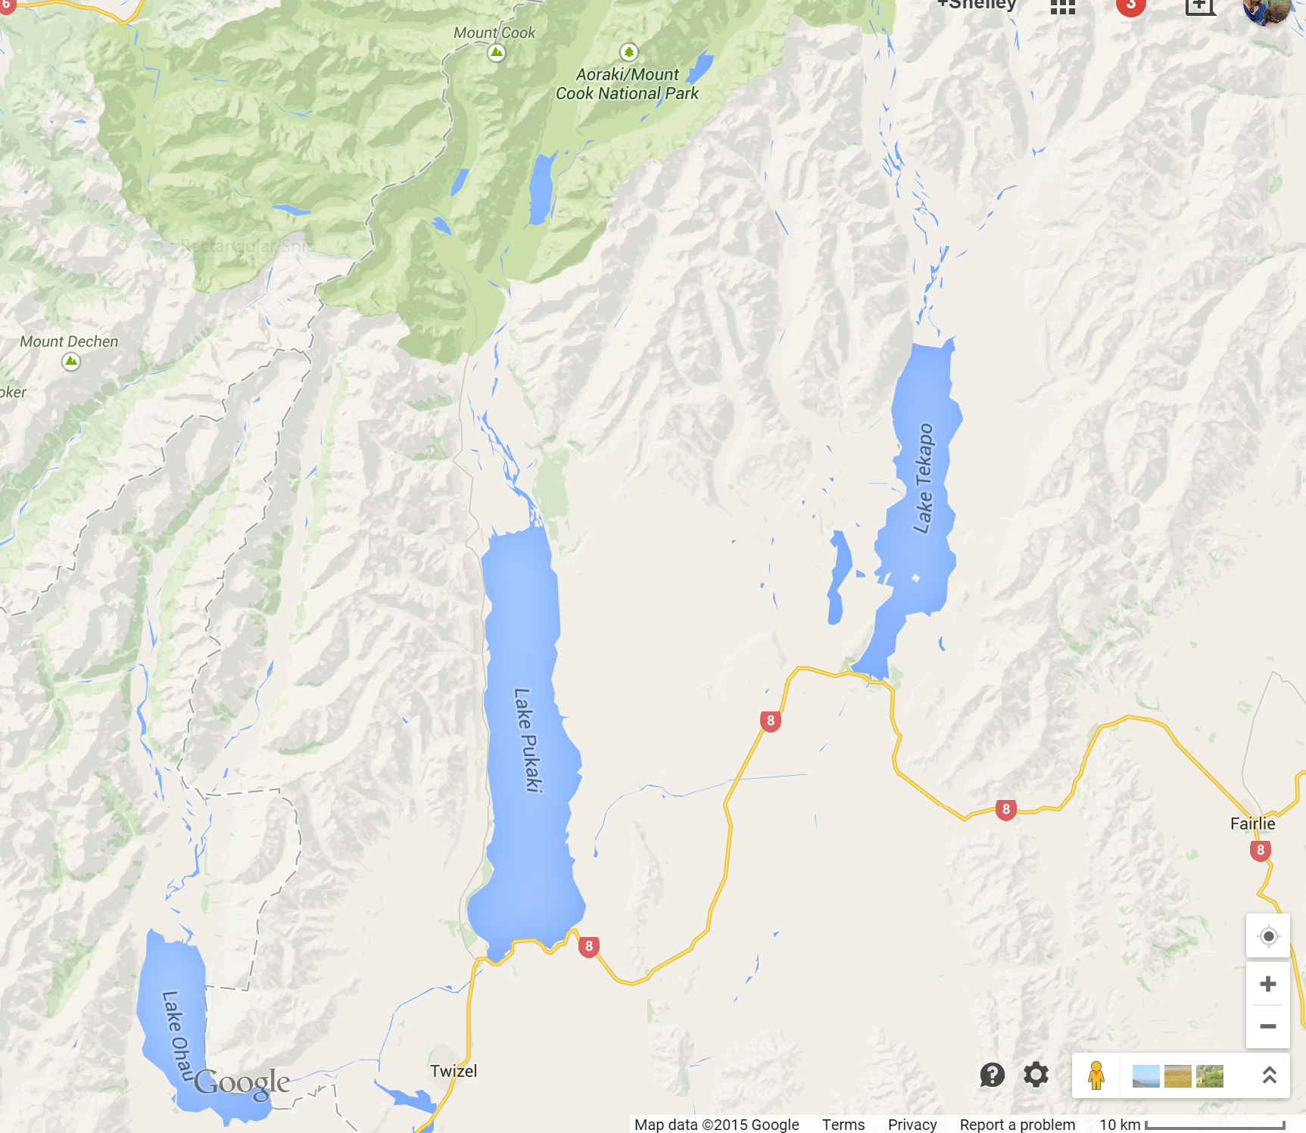
Using google maps, and find the area shown in the map above, then complete the following;
- How many braided rivers can be seen running into high country lakes; 5
- What are these rivers called Hopkins and Dobson flowing into Lake Ohau, Tasman River flows into Lake Pukaki, Godley and Macaulay Rivers flow into Lake Tekapo
- How far (driving) are the following from Twizel and in which direction?
- Aoraki Mount Cook Village 64km, North
- Tekapo 59km, northeast
- Mount John 62km, northeast
- Look at Google Earth or a topographical map of Twizel. What do you notice about the topography (shape of the land) in and around Twizel? Intermontane basin – a basin surrounded by mountains, no forest.
- What is the Māori name of the main range of mountains in this area? Kā Tiritiri o te Moana
- How far is it to drive from Twizel to the coast at Timaru? 163km

